Carbon Nanotube Based Antenna
Concept Generation

FAMU-FSU College of Engineering
EML 4551C
Senior Design Group 16

Group Members:
Natalia Ariza
Justin Bosnoian
Jolie Breaux
Brian Conklin
Edwisht Olmann

Table of Contents
Group Members: 1
Problem Statement 3
Antenna Background 3
Carbon Nanotube Background 5
Past Research and Designs 7
Customer Requirements 8
Slot Antenna Design 9
Carbon Nanotube Concepts 13
Works Cited 16

Problem Statement
Harris Corporation is currently investigating applications of carbon nanotube technology into radio frequency (RF) applications. Carbon nanotube (CNT) technologies have demonstrated properties that are potentially beneficial for these applications. Many of these technologies are still underdeveloped gaining very little practical use. We will explore CNT properties and apply them to design, construct, and test a carbon nanotube slot antenna with a basic breadboard design power source on a small Unmanned Ground System.

Antenna Background
According to Dictionary.com, an antenna is “a metallic device for sending or receiving electromagnetic waves, such as radio waves” (8). An antenna consists of a material that conducts electricity. When an antenna is tuned to the right frequency, using a “tuner”, it will resonate to a radio signal of the same frequency. Radio signals introduce currents into antennas. Antennas then collect the energy and make it available, depending on the application, to perform many tasks such as driving amplifiers in a radio receiver, to make it possible for the human ear to pick up the signal. Antennas are both the “mouth” and the “ears” of communication for radio signals. Without antennas it would not be possible to send or receive information to or from a source wirelessly. Wireless communication is essential in applications such as radio/television broadcasting, cellular phones, radar, and spacecraft communications.
Our customer, the Harris Corporation, is interested in implementing the use of antennas in applications regarding unmanned vehicles (UMV’s). These UMV’s include but are not limited to land, air, and sea applications. The scope of our project only pertains to uses on land, although measures for uses on other platforms are being taken into design considerations.
Due to the tremendous increase in wireless communications, demand for better and more reliable delivery and retrieval systems has also climbed. Therefore the demand for antennas of higher efficiency has increased. In order to answer that there are a few things that must be understood. The first of which is the understanding of a term known as “radiation resistance.” Radiation resistance is defined as, “The total power radiated in all directions divided by the square of net current causing the radiation” (7).
Radiation resistance increases due to charge acceleration. Therefore, the longer the spatial distance of the surface of the antenna the greater the radiation resistance which increases the efficiency of the antenna. Larger antennas are capable of attaining higher capacitance due to their size. Based on our research thus far, the best way to make a small antenna highly efficient is by:
- Maximizing uniformization (single direction) of the flow of current across the surface (this is why CNT orientation is so important).
- Increasing radiation resistance by maximizing the current across the surface.
- Increasing the overall length of the surface (spatial distance) of the antenna to its upper limit keeping within desired resonant frequency range.
- For stationary unmanned systems
- Minimize the number of surrounding objects
- Increase the height (for vertical) or horizontal length(for horizontal) of the antenna
Every structure carrying RF (Radio Frequency) current generates an electromagnetic field and can radiate RF power to some extent. Likewise, an external RF field can introduce currents in the structure. This means that theoretically, any metallic structure can be used as an antenna. However, some structures are more efficient in radiating and receiving RF power than others. With that said, the electrical and physical properties of Carbon Nanotubes (CNT’s) are such that they are desirable as avenues with which to build antennas. Below, in figure #, you can observe a slot antenna design similar to the potential deliverable product.
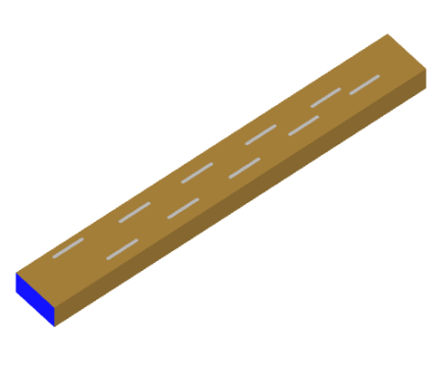
Figure 1: Slot Antenna

Carbon Nanotube Background

Carbon Nanotubes, also known as CNTs, were discovered in 1991 by Sumio Lijima during a period of time in which simple arc-evaporation apparatuses were available and commonly used. While operating this one, Lijima discovered CNTs which are nano-sized cylinders of carbon atoms. The name of these small cylinders is derived from its size; it’s comparable to slicing human hair approximately 60,000 times.
The alignment of the atoms within the carbon nanotubes is a definitive variable that determines which properties the CNT will acquire. Although they are all made of carbon atoms, one may find either chiral, armchair or zig-zag carbon structures. Precisely considering the properties that each of these exhibit, CNTs have become an important area of research for both the industry and the academia.
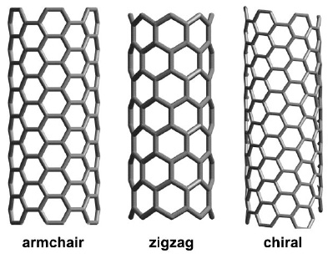
Figure 2: Carbon Atoms Alignment
For instance, through various studies CNTs have proved to be hundreds of times stronger than steel, while being six times lighter. Their radii range from one to three nanometers while their length can go up to a maximum of one centimeter. Besides being strong and lightweight, these cylinders also exhibit high elasticity, and excellent thermal and electrical properties. CNTs are ballistic conductors at which electrons may find a path through the nanotubes where little to no resistance is found.
In reference to their manufacturing methods, there are three major processes used in growing CNTs. One of them is HiPco processing, which stands for High Pressure Carbon Monoxide. During this process, the flow of carbon monoxide gas and clusters of iron through a high heated chamber takes place. Iron acts as a catalyst and after the breakdown of CO and the bonding of certain carbon atoms, the nanotube is created. .
In addition to this process, chemical vapor deposition (CVD) offers a different yet optimal alternative. During this process, once again there is a metal catalyst coated substrate in a heated chamber. However, a process gas and a hydrocarbon gas are induced at a high temperature of approximately 700°C at which carbon breakdown and posterior bonding takes place to form the nanotube lattice that forms CNTs. Besides, the first two methods, there is the plasma enhanced chemical vapour deposition process. This one follows a similar procedure to the CVD, however, the hydrocarbon gas flows through a plasma field. In this process, strong electromagnetic fields determine the orientation of the carbon nanotube growth direction. It is important to clarify that these processes are costly and do not generate a large amount of CNTs. In fact, when a bulk of CNTs is produced, there is a ratio of metallic to semi-conductive structures.

Besides the growth processes of CNTs, there are also distinctions between the number of layers or lattices that may form these cylinders and their energy gaps, which play a critical role in their conductivity properties. Currently, there are single wall carbon nanotubes (SWCNTs) and multiwall carbon nanotubes (MWCNTs).
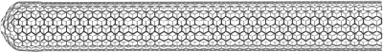
Figure 3: Single Wall Carbon Nanotube
The structure of a SWCNT comes from the folding of the carbon sheet that is formed in the processes discussed above. As observed in figure 3, SWCNTs have a cylindrical structure. The length of this one can be a million times longer than the diameter of the SWCNT. In terms of its electrical properties, a single wall carbon nanotube is also known as a zero-band gap semiconductor since it can be both a metallic and semiconducting tube (1). This ability to conduct electricity is determined by the direction in which the current is induced. It is known that metallic SWCNTs can carry a high current density of up to A . (2)
MWCNTs can also carry a similar range of current density. However, its structure is different since it is not just one sheet of carbon atoms but two or even more folded sheets that form this cylindrical structure. There are two basic models of multiwall tubes, the Russian doll and the parchment model. The first one is formed by a set of concentric tubes wrapped together. The parchment model on the other hand, is only one sheet of carbon atoms rolled multiple times.
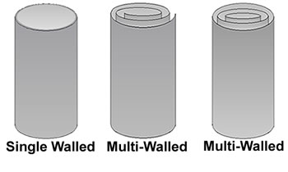
Figure 4: Types of Carbon Nanotubes

As mentioned earlier, CNTs can be metallic or semi-conductive. These two characteristics are distinguished by their band gap or energy gap. In metallic ones, the band gap is non-existent therefore their conductivity abilities are optimal. Semi-conductive reflect a 0 to 2 eV band gap which may still provide a degree of electrical conductivity.
Concerning some of the most important mechanical properties, single wall carbon nanotubes have proven to have the highest young modulus of 1.2 TPa and a very high specific strength of 48,000 kN·m·kg⁻¹ ;which is considerably higher than high carbon steel. In terms of hardness, SWCNTs have demonstrated to surpass a diamond’s hardness which is considered to be one of the hardest materials on Earth. (3)

Past Research and Designs
In research conducted by Zhou et al. a conformal patch antenna was made with vertically aligned carbon nanotubes in a polydimethylsiloxane (PDMS) composite. PDMS was chosen as the polymer because it can be processed at room temperature, has a low loss, and are not sensitive to large changes in temperature. The problem with PDMS is the inability for a good metal-polymer adhesion when it comes to printing circuits or creating conformal antennas. This problem was solved by creating an array of vertically aligned carbon nanotubes. For this project, carbon nanotubes were chosen because they do not oxidize, are not susceptible to moisture and are stable up to 700˚C. In the research, metallic, multiwalled CNTs were used to create a nanofiber density of 3×10⁹ nanofibers/cm². This density of nanotubes allowed for a low resistivity, which in turn lead to a high conductivity sheet of aligned nanotubes. These nanotubes were implanted into the PDMS and then removed from the wafer from which they were grown. This PDMS-CNT sheet is the basis for a conformal antenna that is able to bend and still keep satisfactory antenna properties. Seen below in figure5, is a picture of the finished product being tested on a cylinder in order to determine what change would occur in the electrical properties of the antenna. It was found that the change in properties was minimal, and that this could be a viable way of creating patch antennas that can form to the body on which it is placed. (4)
Figure 5: Testing of Conformal Patch Antenna (Zhou)

Customer Requirements
Harris Corporation would like us to fabricate a conformal carbon nanotube-based slot antenna structure for use by unmanned systems platforms (ex. air, ground, and water surface). The main focus right now is on the ground system applications. Some other requirements are that it’s small enough to apply to a maximum space of 1.5ft x 1.5ft. The antenna should be lightweight, powerful, and overall comparable to antennas of today. Operational parameters include capability with an 802.11b radio at 2.4 – 2.5 GHz wavelength, and linear polarization of 60 degrees. Harris Corporation has specified several different categories to explore.
Our first category focuses on technical features for this application. We will be examining the use of CNT electrical properties, its compatibility with current and future systems, communication with the correct wireless frequency, that it doesn’t obstruct movement of the unmanned vehicle, water resistance and corrosion resistance. After defining these requirements, we were asked to give an importance factor from 1 being the least important to a 10 being the most important.
The second category focuses on ergonomic features for this application. Some specific developments will be directed towards the application of being light weight, durable with rigorous conditions, small sized, optimizing mechanical properties, safety, ease of manufacturability, and compatibility with unmanned systems. Along with the technical features, these requirements are also give and rank of importance to the overall project….revise this sentence
Finally, the last section that Harris is focusing on will be the ‘Ease-of-Use’ of this small light weight carbon nanotube antenna. The main focus for this particular group will be on easy installation, transportation, cost efficiency, and stability. Extreme focus is directed towards the stability of the antenna attached to this small unmanned ground vehicle.

Slot Antenna Design
Antennas can be found in many different shapes and sizes, all of which are equally advantageous depending on the application. In consideration of our design objectives and parameters, the use of a slotted waveguide antenna will be utilized. Slot antennas are of interest in applications in which the RF unit must be positioned inside a metal enclosure. The slot antenna may actually be constructed into the enclosure itself allowing for an embedded and more aerodynamic design; due to this ability, slot antennas are used extensively in aircraft and radar applications. While our design project will focus mainly on ground applications where aerodynamics are fairly negligible, it is in Harris Corporation’s interests that our finished design be not only applicable to ground systems, but air and water surface systems as well.
Before considering actual CNT implementation into the antenna, an initial antenna design must first be established. A typical slot antenna is formed by cutting a rectangular slot into a sheet of conducting material. The slot length must be equal to one half of the wavelength at the desired frequency and the width must be equal to a small fraction of a wavelength (typically a quarter wavelength or less). Consider a horizontal slot antenna. When energy is applied to it, the current spreads out over the entire conducting sheet. The magnetic field lines run horizontally along the length of the slot and the electric field lines run vertically across the width. In this case, the resulting polarization of the radiation will be vertical (there will be horizontal polarization in the case of a vertical slot antenna).
The theory behind electromagnetic radiation tells us that all waves travel at the speed of light (299,792,458 m/s). This number relates both to the frequency () and wavelength () in the following way:
Eq. 1
Our proposed antenna design will be applicable in the 2.4 – 2.5 GHz frequency range. Eq.1 tells us that the corresponding wavelength must be in the range of 4.723 – 4.92 inches; which means that in order for our slot antenna to be functional at the desired frequency it must have a length equal to 2.362 – 2.46 inches (half of the wavelength).
When dealing with navigation, often times waveguides are used. Waveguides are long metal tubes with a rectangular or circular cross section that transfer electromagnetic energy from one place to another. They act as high-pass filters according to the following equation
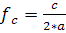 (rectangular cross section) Eq. 2
where corresponds to the cutoff frequency, c is the speed of light and a is the length of the long side of the rectangular cross section. Frequencies above the cutoff frequency will be transported through the waveguide and frequencies that fall below it are attenuated. If constructed with a slot array, a waveguide is effectively made into a slotted waveguide antenna. Since our antenna will be used in the 2.4 – 2.5 GHz range, it will be designed so that the cutoff frequency is 2.3 GHz leaving the length of the long side of the rectangular cross section to be 2.5655 inches. The width of the cross section relates to the forms (or “modes”) of the fields within the waveguide which for now we will leave at 1 inch. A general slot antenna design can be seen in Figures 6 – 8.
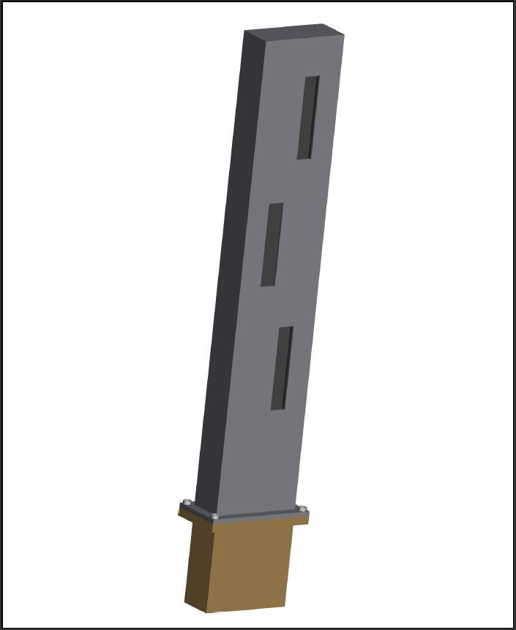
Figure 6: Slotted Waveguide Antenna design. The design uses the concept of a slot antenna to channel the desired frequency into the waveguide antenna.
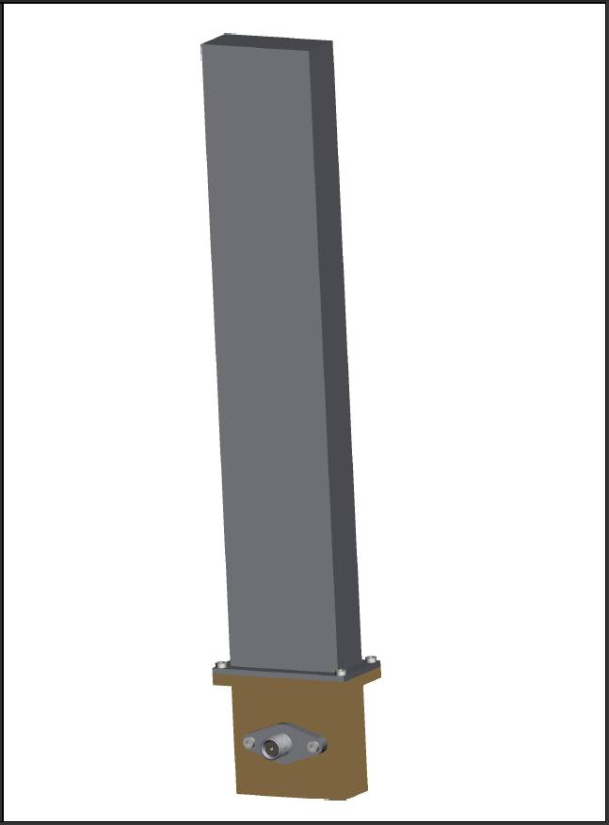
Figure 7: The reverse side of the slotted waveguide antenna with coaxial cable outlet.

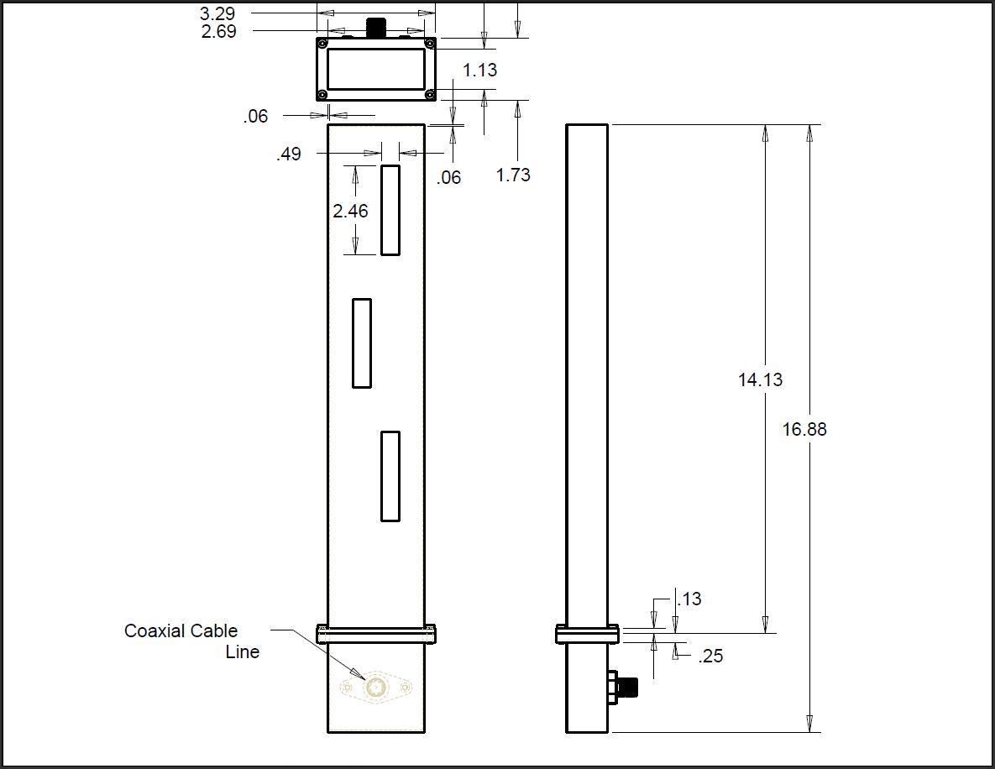
Figure 8: Slotted Waveguide Antenna design drawing.

Carbon Nanotube Concepts
The basis behind most of the concepts utilizes carbon nanotubes’ ability to have different properties depending on how they are formed. Since carbon nanotubes can be either metallic or semiconducting, it is hypothesized that this can be used to create slots or dead zones within an antenna plane by mixing the two types. The metallic nanotubes would conduct and create the magnetic field, while the semiconducting tubes act as the slot by not allowing the current to flow. However, this is theoretical since research has not been done to prove whether or not this concept is viable. There have been processes that can grow ‘forests’ of vertical nanotubes (seen in figure 9) that are semiconducting due to the nano catalyst that was used to start to nanotube growth (1). If this is a possibility, then the combination of conducting and non-conducting carbon nanotubes will allow us to achieve an antenna that acts as a slot antenna but is in actuality a solid plane. The downside to this concept is the chance that the bandgap for the semiconducting nanotubes is very small. In this case it would be possible for the semiconducting tubes to pass current, and although they would not be as good as the metallic CNTs, this possibility could affect the how well the antenna works.
Figure9: “Forest” of Vertically Grown Carbon Nanotubes (Zhou)
Also to be considered is the use of single wall and multi walled nanotubes. It is known that single walled nanotubes are the more conductive of the two species.However,it has been found that technology is unable to grow one type of CNT’s alone. When CNT’s are created, usually only 2/3 of the total amount of CNTs are of the conducting type. This problem could be countered by using multiwalled nanotubes since most of the time the multiwall nanotubes are metallic. This also brings into discussion whether it is possible to create zero current through nanotubes that are connected.
Our final concept takes into account these short comings in the current technology and instead employs a solid polymer slot. This design is based off research that created a patch antenna out of vertically aligned carbon nanotubes. In this research, CNTs were grown vertically then placed inside a polymer. This polymer doped with the vertical CNTs served as a conductor to create the magnetic field for the patch antenna and is also able to conform around surfaces without a significant loss of signal. This antenna can be seen below in figure 10. For our purposes, this will be the most heavily researched design because of the ease of the design as well asthe capability to work off of an existing design that is proven.

Figure 10: Carbon Nanotube Patch Antenna (Zhou)

Conclusion
In conclusion, the voice of our customer (Harris Corporation), specifically ask for certain parameters to be met. Given these certain parameters our team will further explore what the customer wants and how our team will be able solve the problem. Using our project scope in conjunction with the teams combined engineering background, we hope to gather the material needed to complete this project and finalize these designs in order to create an end product that both the team as well as the Harris Corporation are satisfied with.

Works Cited
1. Single-Walled Carbon Nanotube Electronics. Paul L McEuen, Michael S. Fuhrer, and Hongkun Hongkun Park. 1, s.l. : IEEE TRANSACTIONS ON NANOTECHNOLOGY, 2002, Vol. 1.
2. Wafer-level ordered arrays of aligned carbon nanotubes with controlled size and spacing on silicon. Ramkumar Krishnan, Hung Q Nguyen, Carl V Thompson, Wee K Choi and Yong L Foo. s.l. : Institute of Physics Publishing, 2005.
3. Soh, Hyongsok. Integrated Synthesis of Carbon Nanotubes. [Power Point Presentation]. Stanford University.
4. Polymer-Carbon Nanotube Sheets for Conformal Load Bearing Antennas. Yijun Zhou, Yakup Bayram, Feng Du, Liming Dai, John L. Volakis. 7, s.l. : IEEE TRANSACTIONS ON ANTENNAS AND PROPAGATION,, 2010, Vol. 58.
5. The high current-carrying capacity of various carbon nanotube-based buckypapers. Jin Gyu Park, Shu Li, Richard Liang, Xinyu Fan, Chuck Zhang. s.l. : IOP Publishing, 2008, Nanotechnology.
6. "Antennas: The Slotted Waveguide Antenna." Welcome to Antenna-Theory.com - The Antenna Tutorial Website. Web. 14 Oct. 2010. <http://www.antenna-theory.com/antennas/aperture/slottedWaveguide.php>.
7. "Small Antennas and Radiation Resistance." Antennas Radios Amplifiers Baluns and Receiving Systems for HF. Web. 14 Oct. 2010. <http://www.w8ji.com/radiation_resistance.htm>.
8. "Antenna | Define Antenna at Dictionary.com." Dictionary.com | Find the Meanings and Definitions of Words at Dictionary.com. Web. 14 Oct. 2010. <http://dictionary.reference.com/browse/antenna>.

